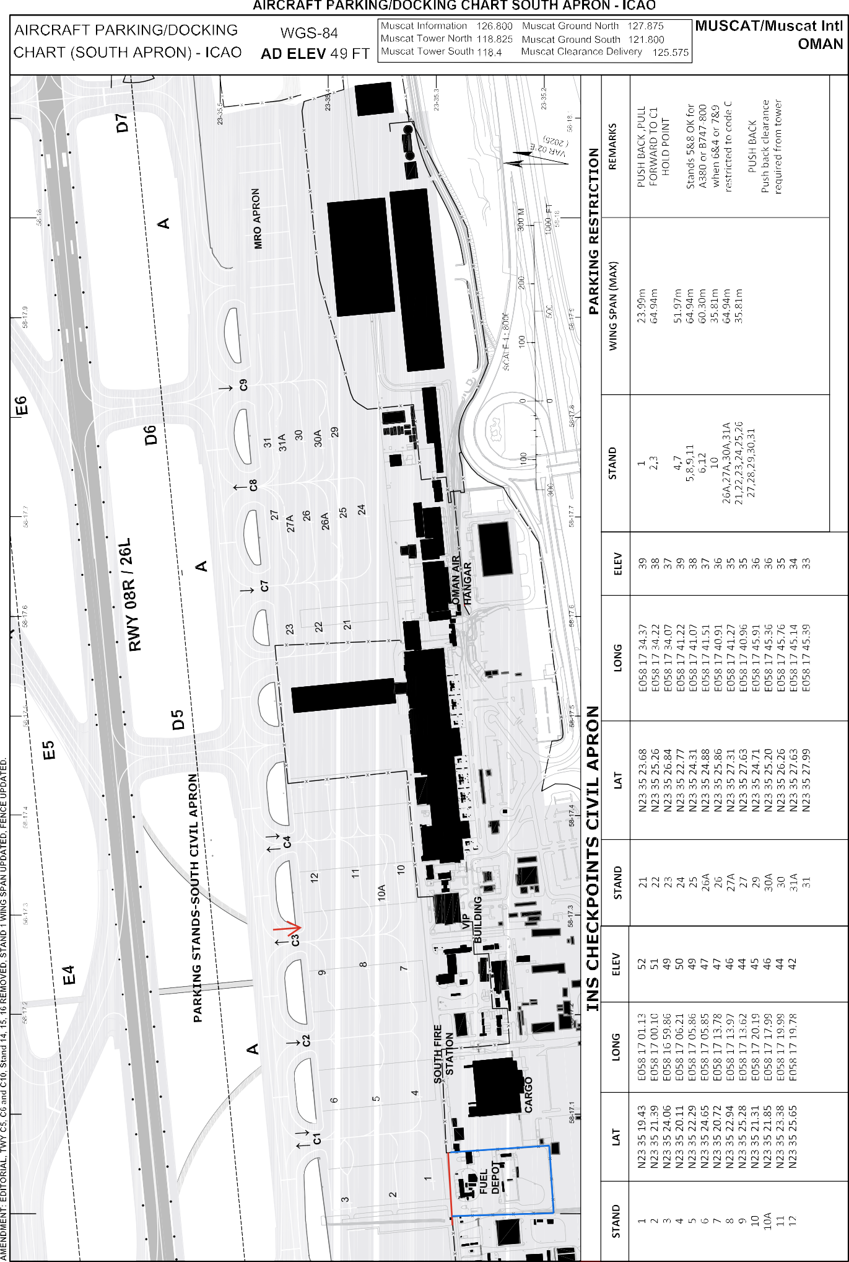AIP OMAN

***2540***

*2024-10-31 12:27:15*

--------------------------------------------

Arrow to be added for entrance

***2540***

*2024-10-31 12:27:46*

--------------------------------------------

Fence to be added

***2882***

*2024-11-03 14:21:29*

--------------------------------------------

to be removed

AD 2.OOMS-29 28 NOV 24

AD 2.OOMS-30 28 NOV 24

AIP

Oman

|  |  |  |  |  |
| --- | --- | --- | --- | --- |
| **INS checkpoints aprons** | | | | |
| Stands | LAT | LONG | ELEV (FT) | Stand Restriction |
| 1 | N23 35 19.43 | E058 17 01.13 | 52 | Up to code B |
| 2 | N23 35 21.39 | E058 17 00.10 | 51 | Up to code E |
| 3 | N23 35 24.06 | E058 16 59.86 | 49 | Up to code E |
| 4 | N23 35 20.11 | E058 17 06.21 | 50 | Up to code D |
| 5 | N23 35 22.29 | E058 17 05.86 | 49 | * Up to code E * Up to Code F (A380 and B748) only when stand 4 and stand 6 are restricted to code C. |
| 6 | N23 35 24.65 | E058 17 05.85 | 47 | Up to code E |
| 7 | N23 35 20.72 | E058 17 13.78 | 47 | Up to code D |
| 8 | N23 35 22.94 | E058 17 13.97 | 46 | * Up to code E * Up to Code F (A380 and B748) only when stand 7 and stand 9 are restricted to code C. |
| 9 | N23 35 25.28 | E058 17 13.62 | 44 | Up to code E |
| 10 | N23 35 21.31 | E058 17 20.19 | 45 | Up to code C |
| 10A | N23 35 21.85 | E058 17 17.99 | 46 | Up to code E only when Stand 10 and stand 11 not occupied |
| 11 | N23 35 23.38 | E058 17 19.99 | 44 | Up to code E |
| 12 | N23 35 25.65 | E058 17 19.78 | 42 | Up to code E |
| 21 | N23 35 23.68 | E058 17 34.37 | 39 | Up to code C |
| 22 | N23 35 25.26 | E058 17 34.22 | 38 | Up to code C |
| 23 | N23 35 26.84 | E058 17 34.07 | 37 | Up to code C |
| 24 | N23 35 22.77 | E058 17 41.22 | 39 | Up to code C |
| 25 | N23 35 24.31 | E058 17 41.07 | 38 | Up to code C |

AIP

Oman

AD 2.OOMS-31

13 JUN 24

|  |  |  |  |  |
| --- | --- | --- | --- | --- |
| 26A | N23 35 24.88 | E058 17 41.51 | 37 | Up to code E only when stand 25 and stand 26 not occupied |
| 26 | N23 35 25.86 | E058 17 40.91 | 36 | Up to code C |
| 27A | N23 35 27.31 | E058 17 41.27 | 35 | Up to code E only when stand 27 and stand 26 not occupied |
| 27 | N23 35 27.63 | E058 17 40.96 | 35 | Up to code C |
| 29 | N23 35 24.71 | E058 17 45.91 | 36 | Up to code C |
| 30A | N23 35 25.20 | E058 17 45.36 | 36 | Up to code E only when stand 29 and stand 30 not occupied |
| 30 | N23 35 26.26 | E058 17 45.76 | 35 | Up to code C |
| 31A | N23 35 27.63 | E058 17 45.14 | 34 | Up to code E only when stand 30 and stand 31 not occupied |
| 31 | N23 35 27.99 | E058 17 45.39 | 33 | Up to code C |